Scanning Instructions

- Log into the computer (214…./214….).

- The scanner will automatically turn on when you pull the stacker on the ADF top section towards you.

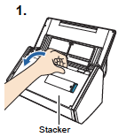

- Prepare to load the document in the ScanSnap.

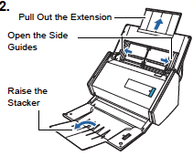
- Load the document on the ADF paper chute (cover), and adjust the side guides to the size of the document. You can fill up to the line (about 10 pages), but the more pages, the larger the file. The machine scans both sides of double sided document.
NOTE: Document FACE DOWN and TOP PAGE FIRST.

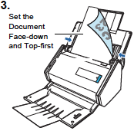

- Press the [Scan] button on the ScanSnap.
- Scanning starts. The Quick Menu appears when scanning is completed

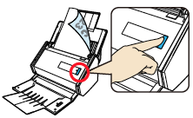

- As the forms are scanning, this will pop up on the computer. Once the forms scan this window will disappear & the SnapScan Manager will open.

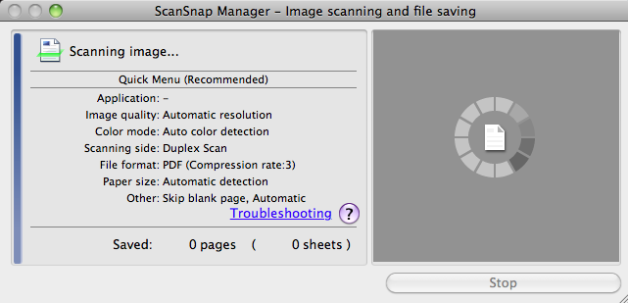

- If it doesn’t start to scan click on the in the dock to open Scan Manager.

- In the SnapScan Manager - Quick Menu, click the icon to choose what you want to do with the document with ScanSnap Manager.

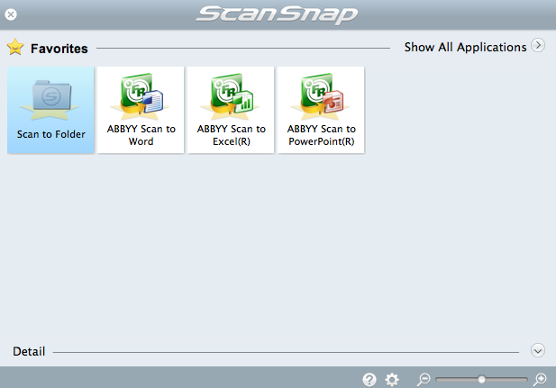

- CHOICE #1: Scanning to Folder. Change the File Name and Location if needed. The default location is the desktop. This will save your document to the desktop – RECOMMENDED (in case something goes wrong). You can drag onto a flash drive or choose to mail to yourself (see next step).

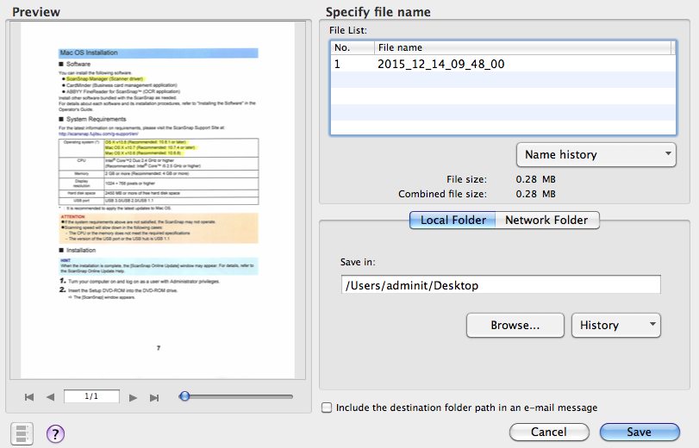
Click on (2015_12..) to change File Name

Change the location path.
/Users/account name/Folder location

- CHOICE #2: Scanning to Email. Save the file to the desktop. Follow Scanning to Folder instructions. Then open up Chrome and your @mules.k12.hi.us gmail account. You can then send the document as an attachment or drag into Google Drive.

- CHOICE #3: Convert to Word, Excel, or Powerpoint. Choose ABBYY Scan to Word, ABBYY Scan to Excel, or ABBYY Scan to PowerPoint. The file converts to Word, Excel, or Powerpoint but there are some editing limitations to the file when the doc opens in Word, Excel, or Powerpoint. Be sure to rename document and change document location to your preference. If you save as a Word document, and drag into Google Drive, it remains a Word Document.

- TRASH your documents from the desktop (for privacy) and EMPTY THE TRASH CAN.

- Log out and close the scanner covers.

