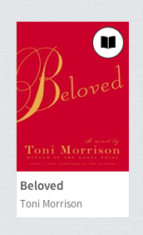
IV. How to download (borrow) a book
- Select the book you want to read
- Note the book in the top right
hand corner is black
2. Click on the book

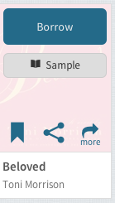
B. When you see this you can Borrow or read a sample

- When you borrow you will see this screen
Select format
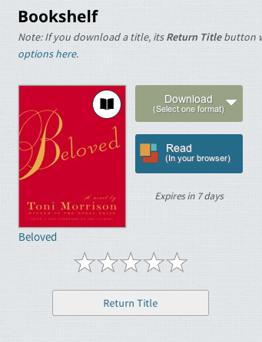

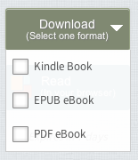

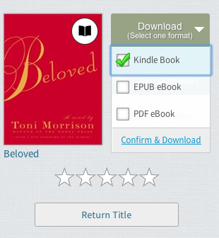
- Select Confirm & Download
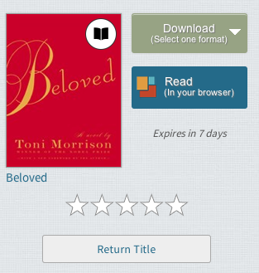
E. Ebook is now checked out

- You may also read ebook in OverDrive
app. See librarians if you have questions

