III. How to find a book on OverDrive
A. Once your are logged into OverDrive, you can start searching for books

You can search by
Subjects, Collections, and Levels
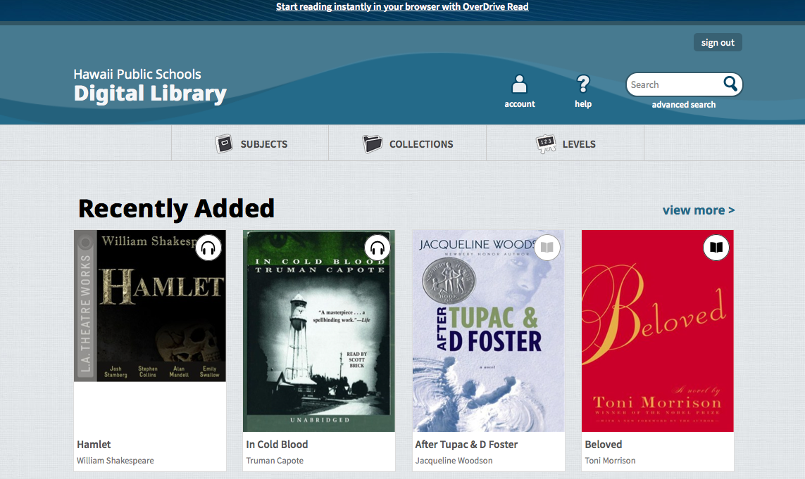

B. Browse each tab (Subject, Collections, and Levels)
1. You may discover that there are many ways to find a book
2. There are different types of materials available
C. Type Search term in the search box

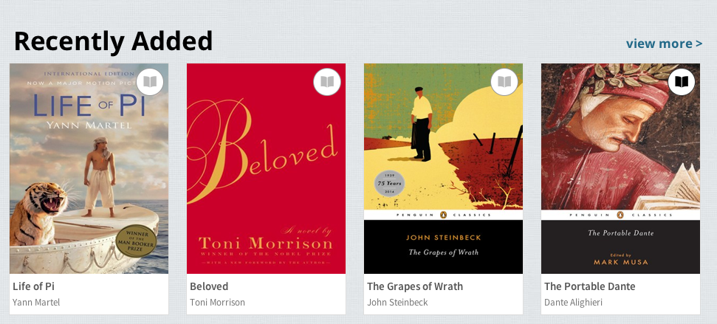
D. Light gray book=Book Unavailable Black book=Book available

