12/1/14

What is OverDrive?
It is an app (application) that allows you to read ebooks.
You can find, borrow, enjoy and return ebooks and audiobooks on a wide variety of compatible tables, phones and computers, all for the tempting price of zero dollars per month! Yes, FREE!

- How to Set up your OverDrive Account
- What you need
  - Your 8 digit teacher ID number
(the one you use on PDE3)
  - Computer to set up Overdrive account

- Where to go
  - Web address
http://hidoe.lib.overdrive.com
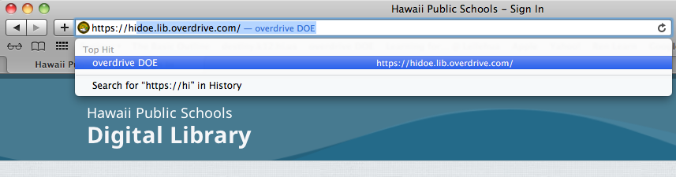

- Next screen is the login screen
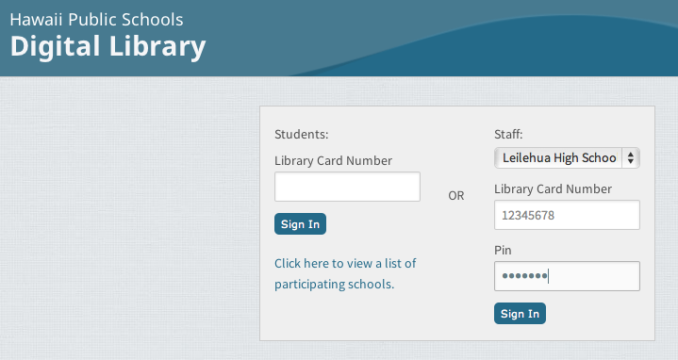
  - Sign in with your school name, Library Card Number(staff ID number) and Pin (Lotus Notes password)
  - Click on sign in

- See Jenny or Yvonne for the next handout:
How to download the OverDrive app to my device?

