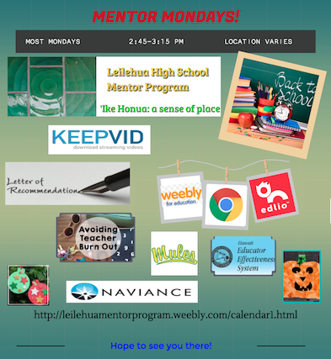
Mentor Mondays for You!
It’s been a long summer –forgotten how stuff works? Want to get some new ideas/strategies to use with your students? Or just have some ‘down time’with your colleagues? Then Mentor Mondays is the time and place for you!

Each Mentor Monday session will have a handout that you can keep for future reference. You can also keep these as EES Professionalism evidence. The first Mentor Monday is next Monday!

When: Monday, August 1
Time: 2:30-3:15
Where: Library

Mentor Monday Topic: School Tools Help Desk
Need help with equipment? Want to learn about different resources in school? Then come to the Library to get help from our Leilehua experts! See one, see all!

*Lotus Notes and/or Telephone –Nate Higa
*Chromebook training (required in order to check out Chomebook labs) and information about using N203 lab independently –Kristy Kaitoku
*RFA –student referral and form –Carla Lum
*Using the laminators –Joni Rabe
*Using the poster machine/Using the scanner –Yvonne Lau
*Library support and services –Jenny Yamamoto
*Comprehensive School Support Services (CSSS) –Kristie Sasamura
*Infinite Campus –Attendance –Erin Yacapin (Location: Registrar’s office)
*Infinite Campus –Q and A–Dion Cabalce

If you have any questions or suggestions for future meetings, please let me know! Check out the Mentor Website for more information: www.leilehuamentorprogram.weebly.com

