Website: http://keepvid.com/

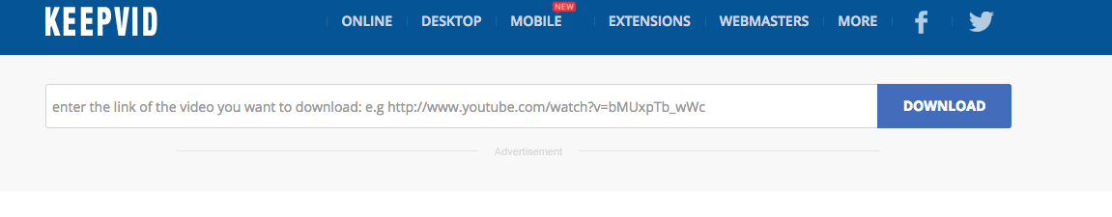
-Copy the URL of the video you want to download
-Enter URL in box
-Click DOWNLOAD
-For video I recommend MP4 720p
-Click on it to download, it will download to computer
-That’s it! You now have your video file. If you’re on your Mac, it’s should be in your Downloads Folder