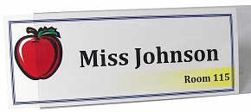
How To Create a Reusable Name Tent
for Parent Conference Week

Create the Name Tent
1. Recycle a used manila folder, cutting off tab

2. Crease the longer ends/edges in approximately 2 inches (both sides). This will
create the base of your name tent.

3. Create your Name using MS Word, landscape layout. You can use
graphics/images to enhance your name. The font used should be bold, and
easy to read. Suggestion: you can add your department or course name, but if
you are not sure, just your name is fine.

4. Copy and paste an exact copy and then modify the margins, etc. to be able to
fit 2 copies on one paper.

5. Print. You can print on colored paper or glue onto construction paper for
added effect.

6. Cut in half.

7. Glue onto the manila folder away from creased edges.

8. Laminate (and log your use on clipboard).

9. Trim and/or fold in and tape edges.

To Assemble
1. Fold into triangle shape with name facing outwards.

2. Overlap the bottom and clip both sides to secure.

3. When done, remove clips and fold flat back into a folder .

4. Put the clips on the folder and file for next year.

Tip: it is a manila folder! Use it to hold the things you want to bring to Conference Week - Syllabus, EGP reports, etc.
