V. Frequently Asked Questions
1. How many books can I check out at once? 3
2. How long is the borrowing period? 7 days
3. Does OverDrive include audiobooks? Yes, just look for the headphones
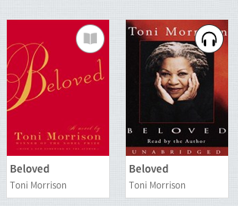
in the top right hand corner and click on the headphones.

*Remember the black headphone means available and the gray
headphone means it is checked out.
4. The technology and policies are constantly changing. It is an evolving program that is in its first year.

