Directions for Teachers to Input Grades for Mid-Quarters
There are 3 options to enter grades. Option 1 and 2 is based on the assumption that the teacher is using the Campus grade book and is up to date in entering assignments and grades. Option 1 will post grades for all classes in mass and Option 2 will need to be done course by course. Option 3 is based on the assumption that the teacher is not using the Campus grade book or would prefer to enter grades manually.

Option 1
- Log into Campus and click on Post Grades in the index
- Be sure the Term, Section and Task drop down are correct. This example will be based on Quarter 1
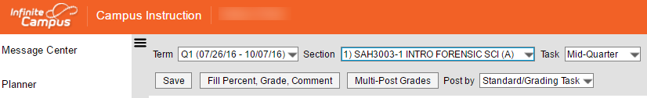
- Click on the Multi-Post Grades button
- Complete Step 1, then click Next
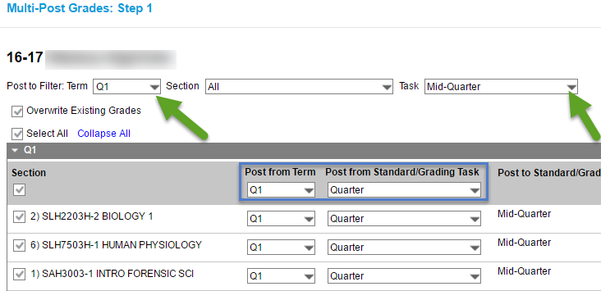
- In Step 2, click on the Post button on the bottom right and click Close
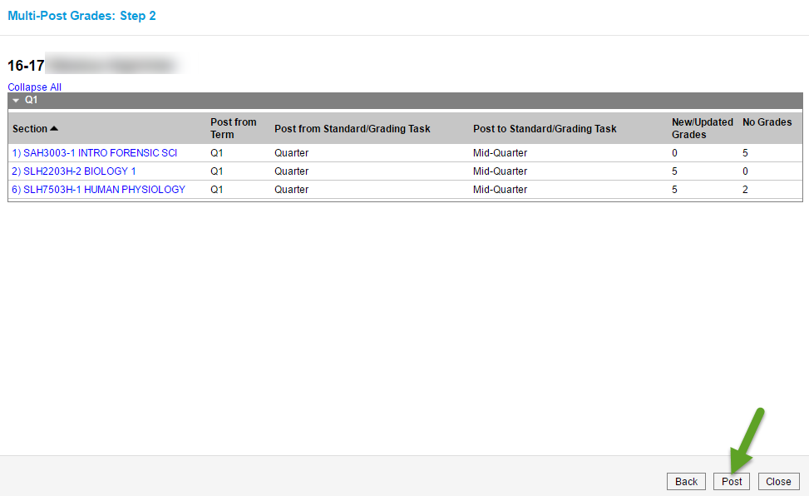

Option 2
- Log into Campus and click on Grade Book in the index
- Be sure the Term, Section and Task drop down are correct. This example will be based on Quarter 1
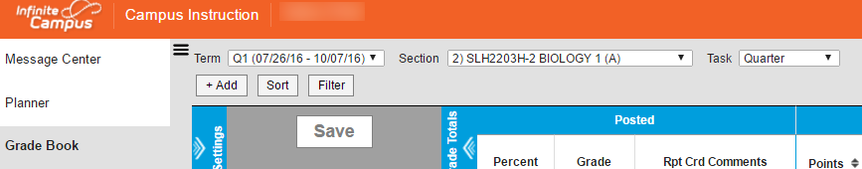
- Click on Post in the In Progress column
- In the pop-up, be sure the Term is Q1 and change the Task to Mid-Quarter, then click OK
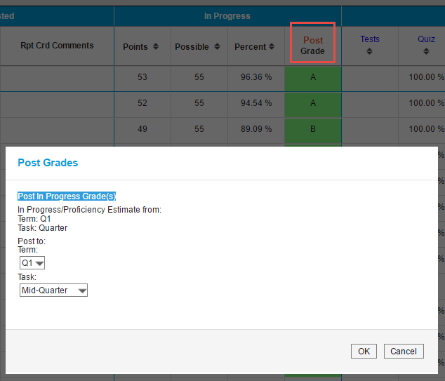
- Click on OK in the Warning pop-up
- Teachers can input comments by clicking on CC (Canned Comments) in the Rpt Crd Comments column for individual students, or by clicking on Fill which will allow mass assigning of comments. Teachers can enter multiple comments per student.

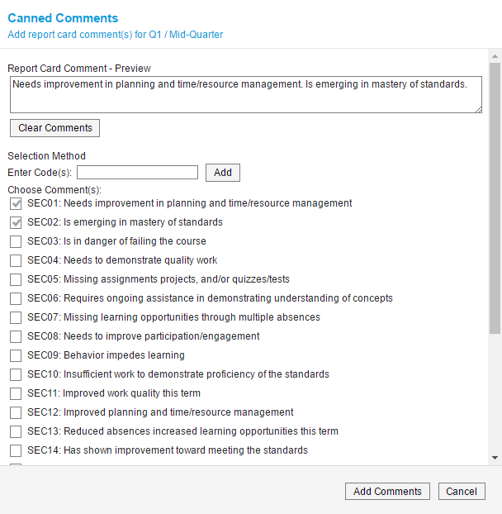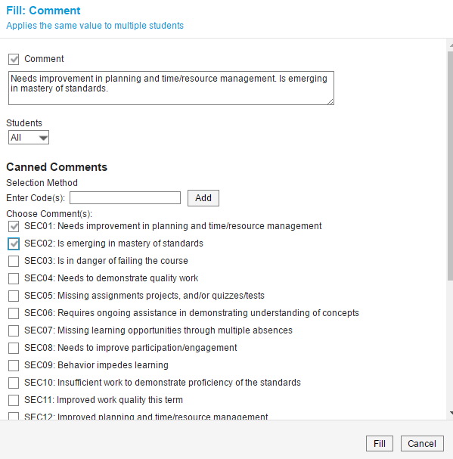
- Teachers also have the ability to edit individual marks by clicking on the letter or empty space in the Grade column and then click Save
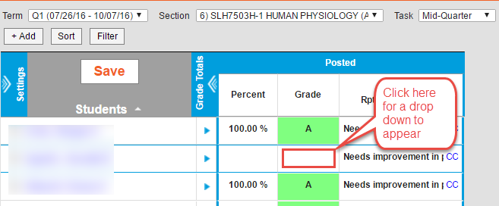

Option 3
- Log into Campus and click on Post Grades in the index
- Be sure the Term, Section and Task drop down are correct. This example will be based on Quarter 1
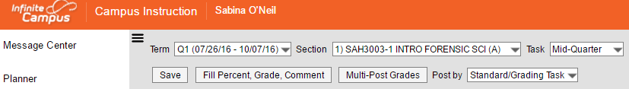
- Teachers can input grades for one student at a time by clicking on the drop down in the Grade column and selecting the appropriate grade
- Teachers can input canned comments for one student at a time by clicking on the add button in the Canned Comment column and selecting the appropriate comment(s)
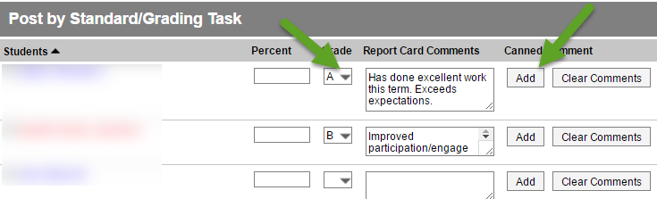
- Teachers can input grades and comments in mass by clicking on the Fill Percent, Grade, Comment button and selecting the appropriate grades and comments and click Fill
  - Please note this will be added to all students on the roster
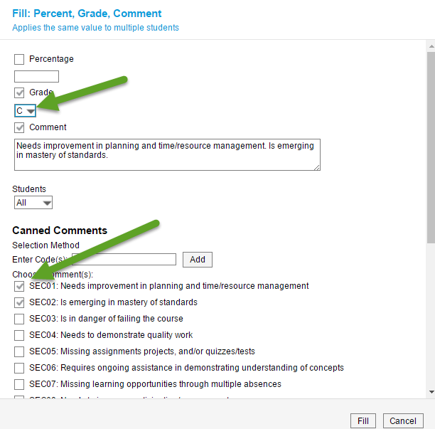
- Click Save at the top left

