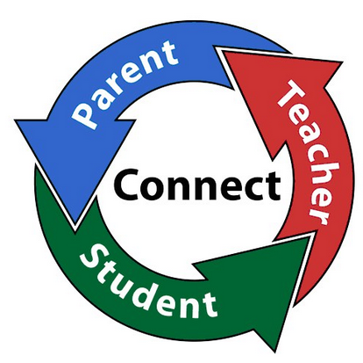
Parent Conference Week Opportunity

Our tradition of fundraising during Conference Week continues! If anyone would like to sell items for a school sanctioned club or organization, please fill out the form below and return to me. We would like a variety of items, so first to sign up for an item has priority. If the group can only sell on certain days, we can combine groups selling the same item to cover all three days.

Details:
1. We will be stationed along the lanai from the library to Culinary, so benches are available for seating.
2. You will need to provide your own table, equipment and staffing
3. There are no power outlets, other than the registrar, so you will need to make arrangements with them directly.
4. Plan on selling on all three conference days, for all hours, until you are sold out.

Timeline:
September 29 Send out informational flyer to DHs and sign up begins
October 17 Sign up for lanai area at the library
May be based on electrical needs, etc.
October 31 Parent Conference Week begins

Let me know if you have any questions and/or suggestions!

~Sandi

(Complete this form and return to S. Maruyama)

Name: ____________________________ Dept/Program: __________________

Yes! I would like to have a table at the Parent Conference Week

Item to sell: ______________________________

____ I am able to sell all three days

____ I can only sell on these days:
___ Monday (short day) ___Tue (long) ___Wed (long)

