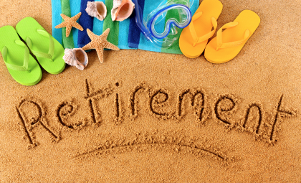
5 Factors of Healthy Aging

1. No Longer Defined by My Job
*What’s my ‘job’ v. How will I live meaningfully?
*Opportunity to make a difference in a new way
*What does ‘meaningful use of time’ mean? No longer attached to money.
*Be cognizant of emotional aspect of being retired

2. Find Your Social Group
*How do you find opportunities to interact with others in a genuine way?
*”Third phase” of life – developing new groups of friends, community
*Do not listen to the ‘youth culture’ that says we are ‘done’ (ageism is an
attitude)

3. Managing Your Resources
*Treasure – have a financial plan to take care of yourself and family
*Time – what will you do with your time? Caregiving? Volunteering?
*Talent – you have wisdom to share with others, skills that have been
developed over time. “Personal equity” resource.

4. Wellness – not just the absence of disease but presence of health
*be aware of developing healthy habits
*mental health equally important
*consider the value of simplifying your life

5. Spiritual – have the time to:
*reflect on the ‘bigger picture’ – what is my legacy?
*realize our time on earth is finite
*think about what is the meaning of life/existentialism

Other articles about aging “gracefully”
*50 tips for aging gracefully
http://www.ecumen.org/resources/50-tips-aging-gracefully-ecumen#.Vuik_ilAXOU

*9 things people aging gracefully do differently
http://www.huffingtonpost.com/2015/06/05/what-people-aging-gracefully-do-differently_n_7469644.html

