How do I share a document with others?

1. You can upload or create in Google Drive a document/file that you created on your desktop. For this exercise, we will upload a document.

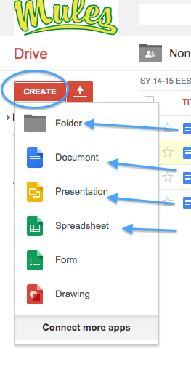
2. Click on the upload icon and identify if it is a file or folder. Navigate to the place the document resides on your computer.

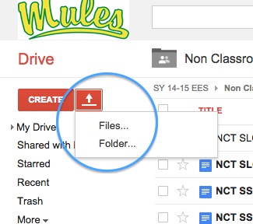

3. Once you select your document, drive will confirm you want to share document. Click on ‘upload and share’.
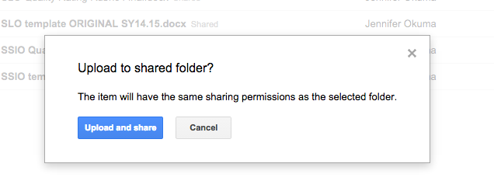

4. A pop up screen will appear confirming it has been uploaded. Now you need to decide who to share it with. Once that is done, go back to the checked document, click on More and then set who will ‘see’ and to what extent (can edit, can comment, can view). You can add more viewers, add a message, send it to yourself, etc. You choose. Then send.

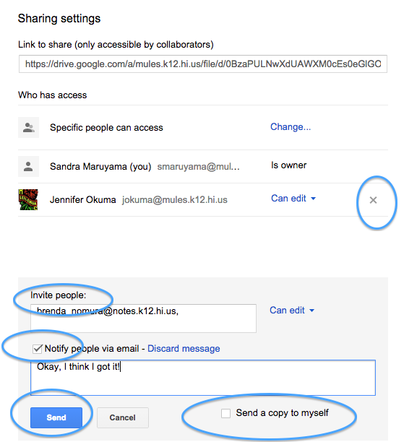

Some issues that may arise.

1. Having problems with an MS Word document and Google Drive/Docs?

*After you upload the MS Word document, check it and click on "More". Copy the document. Once you do that, it becomes a Google document that you can then 'share'.

*If you create a document in Google docs and try to download into MS Word, there may be formatting issues.

*If you have problems printing a Google doc, open Google with Chrome (not Firefox or Safari)

