How do I access a document that was shared with me?

1. First, you probably received an email from the other person, alerting you to check your gmail account – navigate to google drive.

2. In Drive, you will first see files and documents you have created and stored there
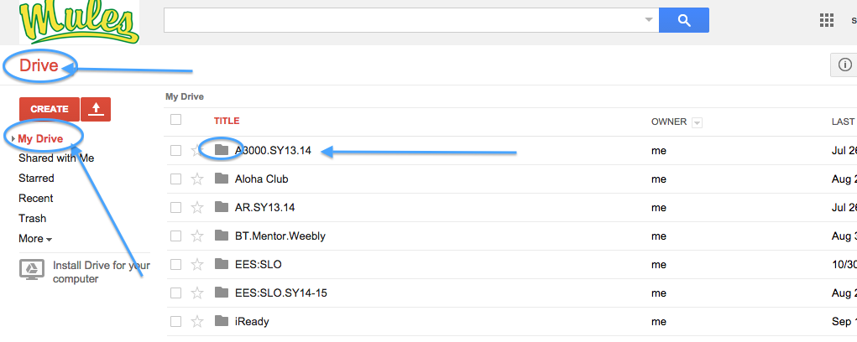

3. Click on the choice below titled, “Shared with me”. You should now see any files and documents that have been sent to you. The documents appear as a list (like the one below) or by icons.
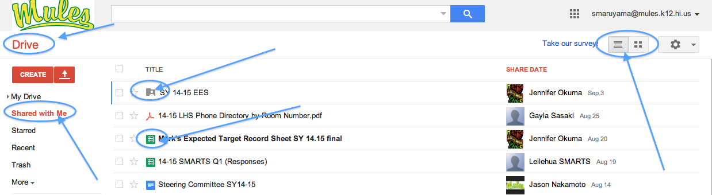

4. If it is a file, click on the title of the file to open it. Try the EES one. After you click on the title, you should see these folders. Then click on Classroom Teacher (or NCT).

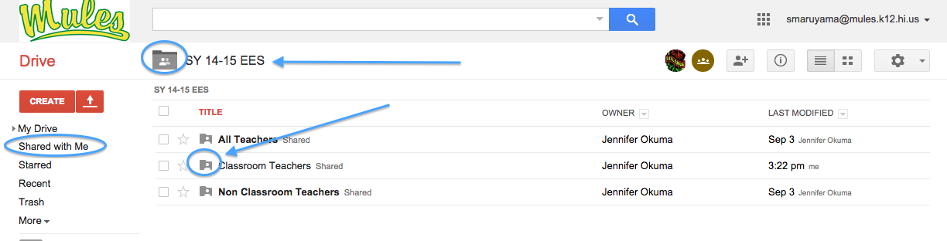

5. When you see the document you want, check the box and the “more” option at the top will become available. Pull down the menu to see your options.

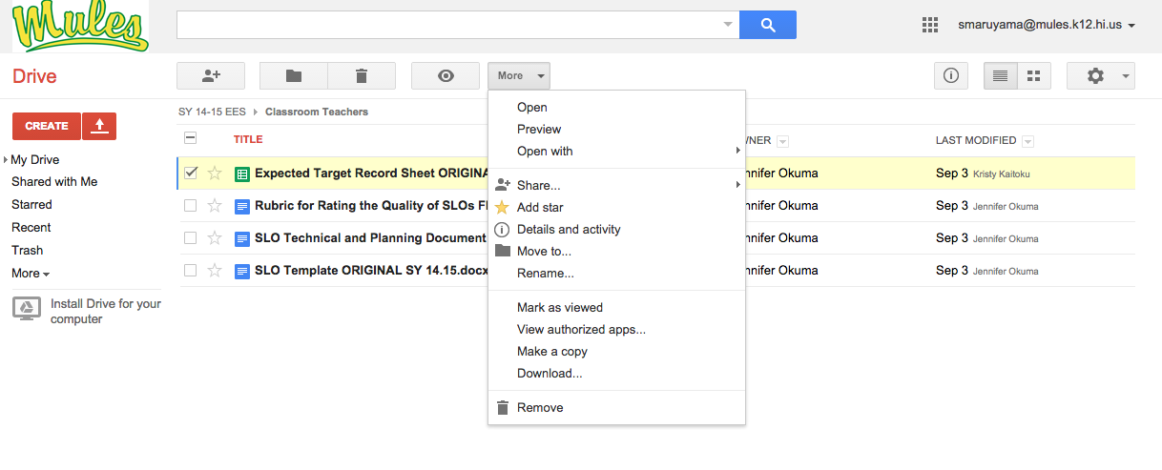
6. You have TWO (2) options at this point.

You can MAKE A COPY, which will make a copy in the ‘cloud’ that you can work on 24/7 from anywhere with Internet access. For this exercise, we will choose MAKE A COPY.
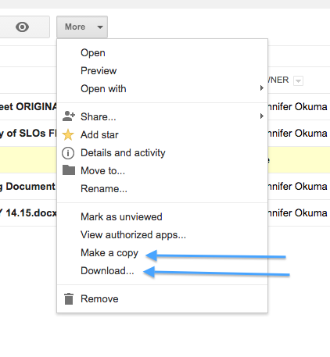
You can DOWNLOAD the checked document. This means you are going to download the document to your desktop/laptop and it will only appear on that specific computer. Note: the downloaded document can be accessed by clicking on its name in the bottom left hand corner.

7. Under the “More” tab, click Make a copy. A copy of the document you checked off will appear, named “copy of….”. This copy is now in the ‘cloud’ for you to work on.

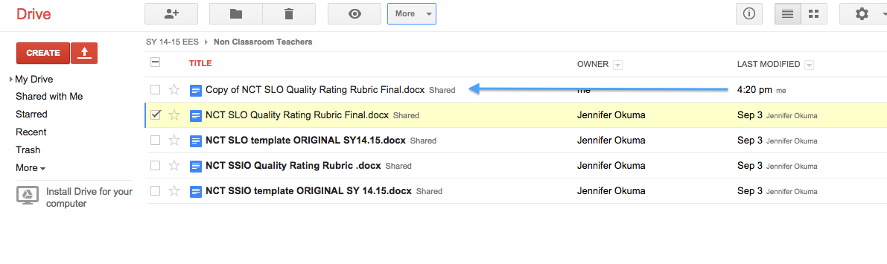

8. Uncheck the original document box. Then check the ‘copy’ document. Then click “More”. Click on ‘rename’ to rename the document. It should appear on your list with the new name after you say ‘okay’.

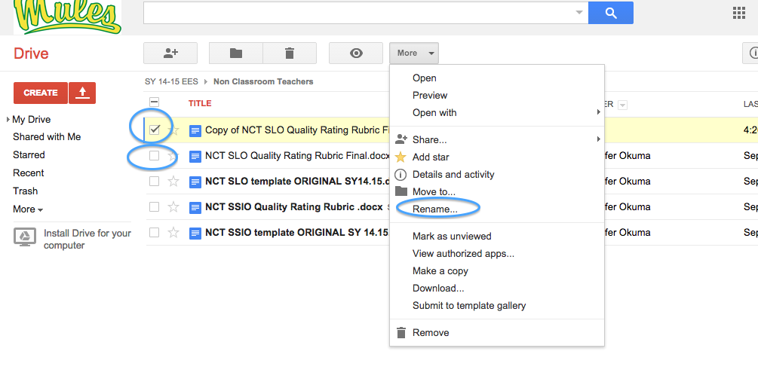

9. Who do you want to see this document? Just you? Certain people? All of us? Limit who can and cannot see this document. Click on the renamed document, click on More, Click on Share, Click on Share.
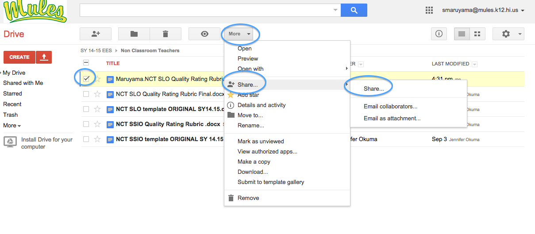

10. On this screen, select who you want to share with. It automatically defaults to only specified people/lists unless you “change”. If you click on the “X” it removes them from the list. And you can ‘invite’ people to view the document.

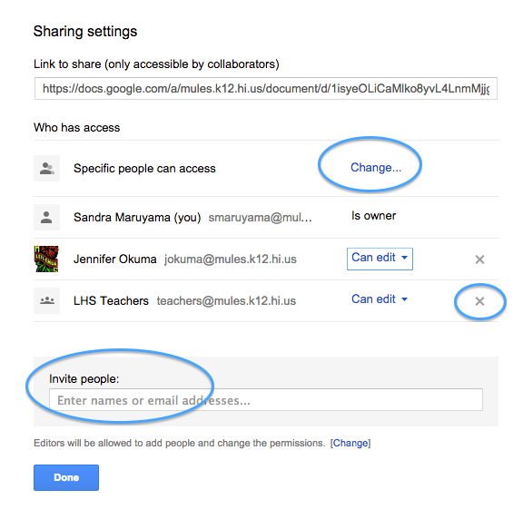

11. What rights do you want to give the others? Once your list is set, click on the ‘can edit’ button to see your three choices: (1) Can edit – they can modify your document – full access (2) Can comment – they can make comments, but you have to approve any changes they make (3) Can view – they can only view but not change. YOU decide. Press done.
