Mentor Mondays – Google Drive – Basics

Terminology
application - computer program
cloud - storage; a big flash drive in the sky
google drive - a file storage and synchronization service used for cloud storage, file sharing and collaborative editing. You can make documents, spreadsheets, surveys, etc. Google docs live here.

Icons - the icons represent different items you can create in Drive
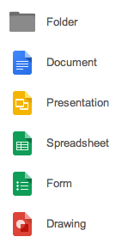

Why use Google Drive?
1. The documents ‘live’ in the ‘cloud’ (on google’s server) – this means you can access it anywhere/anytime with an internet connection. It does not ‘live’ on your individual laptop/desktop.

2. It saves time – instead of having to send documents via email, you can allow preferred people to see it immediately

3. It saves space on Lotus Notes – If you get those unfriendly ‘quota’ notices, you can bypass L/Notes with google docs.

4. Multiple people can work on the same document at the same time or when it is convenient for them – if your LT is working on a SLO, you can all make changes to it and every member can see the changes.

What are some of the basic things I can do in google/google drive?
*internet searching with Chrome (google’s web browser – think Firefox, Safari)
*email (gmail.com)
*manage your documents in google drive (where your documents live)
*set up an address book (contacts)
*set up a calendar for you and your family

Examples of how Google Drive can help you
* Core Professionalism - Collaboration with LTs for SLO
* EES – Use in instruction and tudent engagement, instruction and assessment data

How to access google drive
1. Open up Chrome (or Firefox if you don’t have Chrome)
2. Go to url: gmail.com
3. Type in your Leilehua account information (see tech if you need help):
*example: user name: bnomura@mules.k12.hi.us
password: XXXXXXXX
Sign in
4. You are in your email. In the top right hand corner, click on the icon that looks like a grid. This is where the google applications reside.
                      
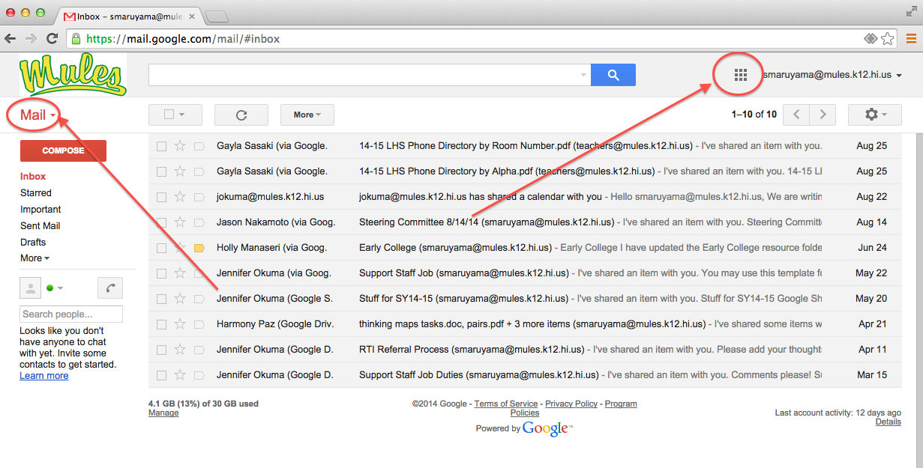

5. When you click on it you should see this:
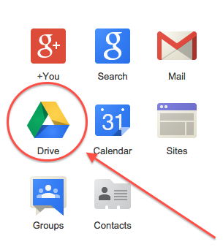You can see the choices of applications = contacts, calendar, mail, etc. Click on DRIVE.

6. In Drive, you will see a list of documents on a screen that looks similar to email, but it is different. You are now in google drive.

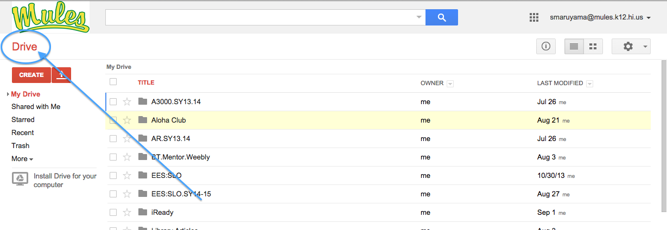

7. When you are done remember to sign out (top right corner).

